**R2D2 – 16 Bit Addressing:**

PE24103 device named as R2D2 is supporting two protocols.

* 1. I2C – Operates in 16 bit addressing format. (Device Address : 0x38)
* 2. PMBus – Operates in 8 bit addressing format.(Device Address : 0x30)

Inorder to load the 16 bit I2C of R2D2- use command line argument: /16bitaddressing

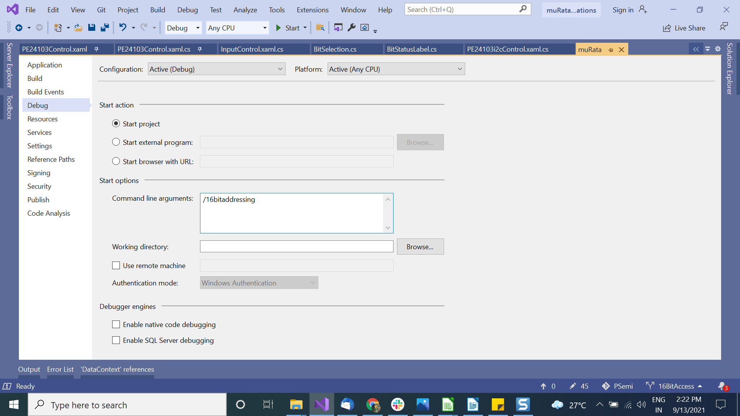Hence,

with command line argument(/16bitaddressing) : Load I2C Protocol

without command line argument : Load PMBus Protocol

The 16 bit registers for I2C are placed under the I2CRegisters element in device configuration file.

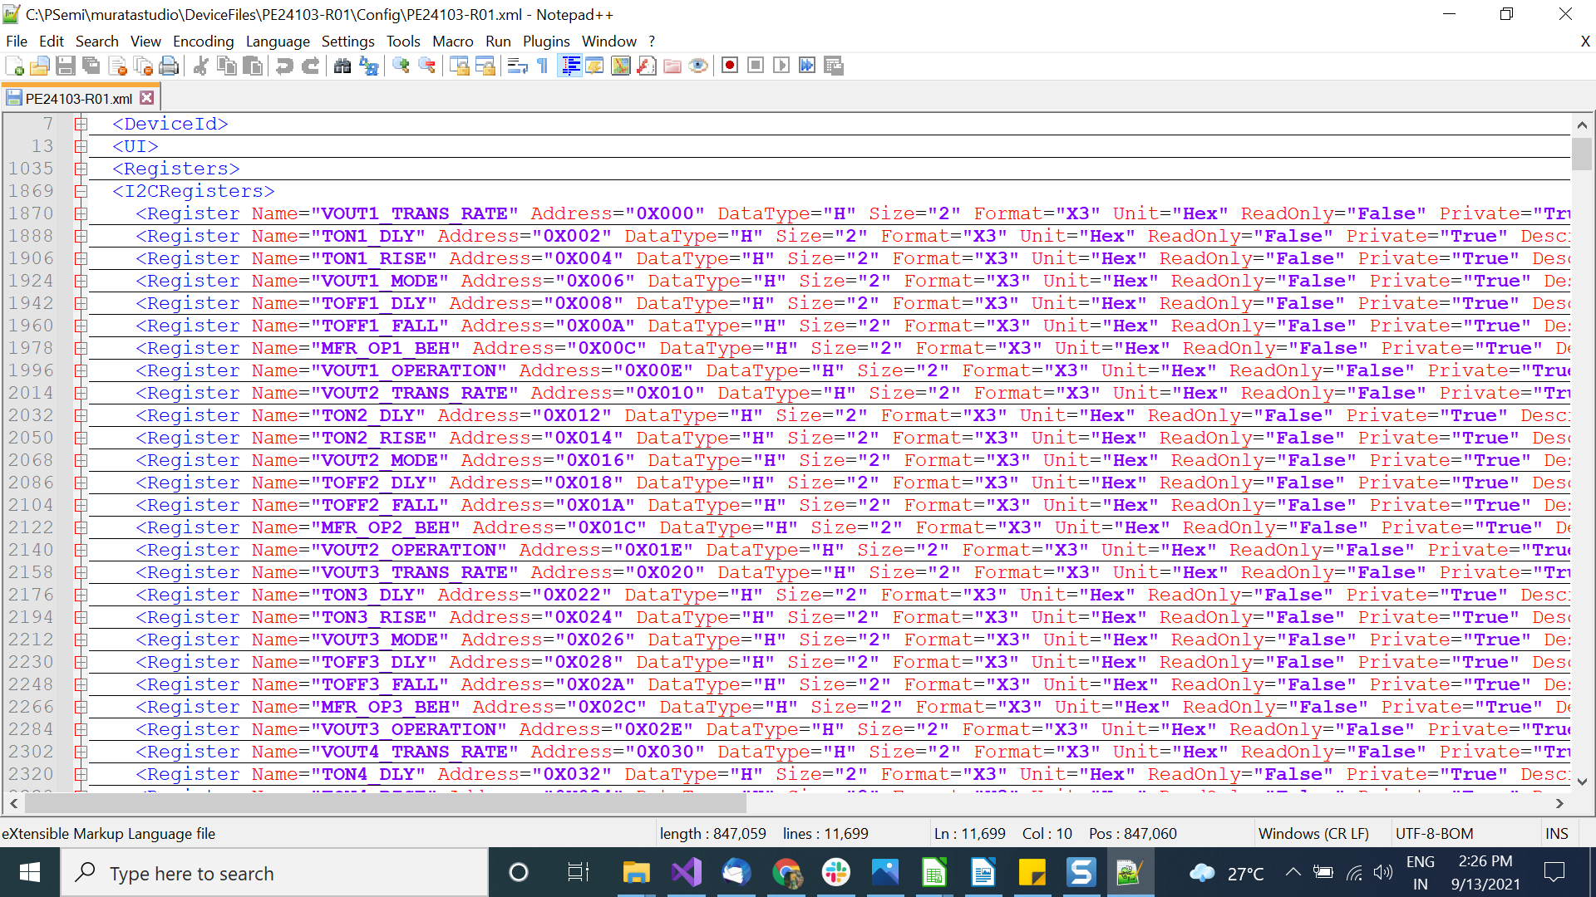

Registers added in the above section will be shown on the Registers Tab of Murata Application and will load the 16bit registers

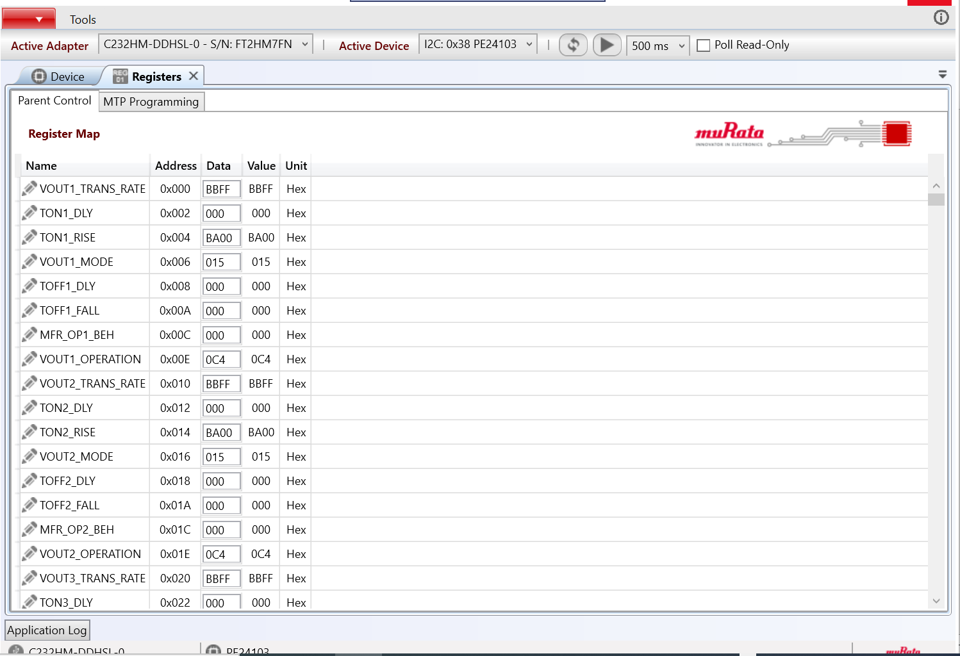Apparently the Protocol Tab in the application will allow us to do read/write operations in the GUI for 16 bit register address.

For establishing a connection in R2D2 i2c Device,we need to enter Master Test mode by necessary writing  **0xA596 to Reg0x3FD** register every time you restart the power cycle.

***R2D2 16 bit Registers include two types:***

**1. MTP Registers**  - Cannot do the read/write operations to these registers directly, possible via MTP Programming

**2. RW Registers** - Able to do the read/write operations to these registers once connection(3FD) is established after each power cycle(means enter Master Test mode).

**MTP PROGRAMMING :**

**I**nroder to do MTP Programming, we have to know the MTP Page .

Page is nothing but the group of MTP registers that we consider for MTP Programming. Each 8 registers starting from 0x000 form a page so that R2D2 contain total 32 pages ( 32*8 = 256 MTP Registers) . MTP Programming is done based on Page.

**32 PAGES**

|  |  |  |  |
| --- | --- | --- | --- |
| 000 | 010 | 020 | 030 |
| 040 | 050 | 060 | 070 |
| 080 | 090 | 0A0 | 0B0 |
| 0C0 | 0D0 | 0E0 | 00F0 |
| 100 | 110 | 120 | 130 |
| 140 | 150 | 160 | 170 |
| 180 | 190 | 1A0 | 1B0 |
| 1C0 | 1D0 | 1E0 | 1F0 |

**Following are the steps do the MTP Programming**

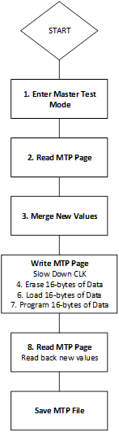

1. Enter Master test mode (Write A596 to 0x3FD)

2. Select a Page so that it will load the 8 registers belonging to that page.

3. If the user want to edit the Page register value, then they can edit it from the cell.

4. Write MTP page includes:

1. 1.Slow down clock means write 0x55A0 to Reg0x29F - CLK needs to be slowed down to write data.
2. 2. Erase the existing values in the registers

ERASE the 16-bytes of data in a PAGE by writing the following value to the mentioned register address

|  |  |
| --- | --- |
| **VALUE** | **REG ADD** |
| 0x00F0 | 3D3 |
| 0xF022 | 3D1 |

Test the reg values of MTP registers to confirm erasing is done. (20 ms, VALUE should be FFFF).

|  |  |
| --- | --- |
| **MTP** | **VALUE** |
| 00F0 | FFFF |
| 00F2 | FFFF |
| 00F4 | FFFF |
| 00F6 | FFFF |
| 00F8 | FFFF |
| 00FA | FFFF |
| 00FC | FFFF |
| 00FE | FFFF |

Once the Erasing is done write/edit the new values in GUI .

3. Program the assigned Data values to the MTP Registers by

TRIGGER PAGE PROGRAM the 16-bytes of data.

|  |  |
| --- | --- |
| **VALUE** | **REG ADD** |
| 0x00F0 | 3D3 |
| 0xC012 | 3D1 |

Read back the values at Page to confirm the values.

